**Experiment-9**

**9.1) Implement a Python script to illustrate constructor**.

**Program:**

class Employee:

def __init__(self,name,id):

self.id=id

self.name=name

def display(self):

print("ID:%d\nName:%s"%(self.id,self.name))

emp1=Employee("ravi",101)

emp2=Employee("sunitha",102)

emp1.display()

emp2.display()

**Output:**

ID:101

Name:ravi

ID:102

Name:sunitha

**9.2) Implement a Python script on Class variables, instance variable and illustration of the self variable.**

**Program:**

class Employee(object):

def __init__(self,_num=0,_name='',_salary=0.0):

self.num=_num

self.name=_name

self.salary=_salary

def print_data(self):

print('EmpId:{},EmpName:{},EmpSalary:{}'.format(self.num,self.name,self.salary))

def calculate_tax(self):

print('Processing tax for:....')

self.print_data()

slab=(self.salary*12)-300000

tax=0

if slab>0:

tax=slab*0.1

print("Tax:",tax)

e1=Employee(1234,'John',23600.0)

e2=Employee(1235,'Samanta',45000.0)

e1.calculate_tax()

e2.calculate_tax()

**Output:**

Processing tax for:....

EmpId:1234,EmpName:John,EmpSalary:23600.0

Tax: 0

Processing tax for:....

EmpId:1235,EmpName:Samanta,EmpSalary:45000.0

Tax: 24000.0

**9.3) Implement a Python script to handle exceptions.**

**Program:**

print("Program Started")

try:

print("Outer try block entered")

try:

print("Inner try block entered")

raise IndexError

except IndexError as e:

print("Something went wrong",e)

else:

print("No exceptions")

print(2/0)

except ZeroDivisionError:

print("Caught in Outer try")

raise

finally:

print("End of program")

**Output:**

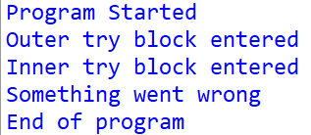

**10.2)Implement a Python script to implement the following figures using turtle**

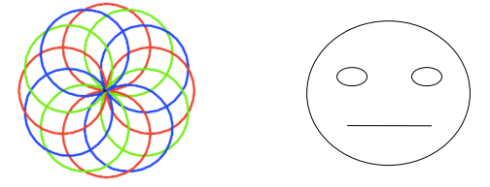

**Program:**

import turtle as t

i=0

color=["blue","red","green"]

for x in range(0,360,30):

t.pencolor(color[i%3])

t.circle(50)

t.seth(x+30)

i=i+1

t.done()

**Output:**

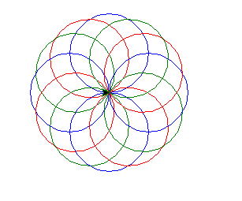

import turtle as t

s=t.Turtle()

s.circle(100)

s.penup()#left eye

s.goto(-50,100)

s.pendown()

s.circle(20)

s.penup()#right eye

s.goto(50,100)

s.pendown()

s.circle(20)

s.penup()#mouth

s.goto(-30,50)

s.pendown()

s.forward(60)

s.hideturtle()#hide turtle

t.done()

**Output:**

